**Animal HealthCare**

**An Engineering Project in Community Service**

**Phase – I Report**

***Submitted by***

**Utkarsh Kumar 20BCE10622**

**Shivansh Shukla 20BCE10559**

**Abhishek Thapliyal 20BCE10231**

**Priyanshu Nagariya 20BCE10814**

**Piyush Das 20BCE10642**

**Radhika Gour 20MIP10021**

**Shivam Kumar 20MIM10126**

**Sahil Singh Kushwaha 20BAI10172**

***in partial fulfillment of the requirements for the degree of***

***Bachelor of Engineering and Technology***



**VIT Bhopal University**

**Bhopal**

**Madhya Pradesh**

**December, 2022**



**Bonafide Certificate**

Certified that this project report titled **“Animal HealthCare”** is the bonafide work of **Utkarsh Kumar 20BCE10622, Shivansh Shukla 20BCE10559, Abhishek Thapliyal 20BCE10231, Priyanshu Nagariya 20BCE10814,Piyush Das 20BCE10642, Radhika Gour 20MIP10021, Shivam Kumar 20MIM10126, Sahil Singh Kushwaha 20BAI10172”** who carried out the project work under my supervision.

This project report (Phase I) is submitted for the Project Viva-Voice examination held on 29th December,2022.

**Supervisor**

**Dr.Suparna Patowary-SBE**

# INTRODUCTION

Animal healthcare is a setting for animals that enables us to offer them all the amenities in one location. From the time of an animal's birth until the time of its death, we offer all the necessary assistance in this service-providing environment. This includes providing any animal with all necessary medical treatment as well as mentoring and physical, mental, and emotional support. For active use, professionals including doctors, dieticians, trainers, and NGO's are accessible. This will give people a fantastic opportunity to take care of their pets.

## MOTIVATION

Consider the lives of street animals who have no one to care for them. Our great ambition is to provide any form of assistance to all animals. In today's world, a person with a pet does his or her hardest to provide all the facilities to his or her pet, but sometimes fails.

.

## OBJECTIVE

* To reach out all animals who need help
* To provide better heathcare facilities to animal
* To reduce a death ratio of street animals
* To provide shelters to street animals
* To provide dietcians,trainers,doctors to pet owners
* To give information to NGO's about ownerless animals.
* To help people who are making animal product by allowing them to sell the product to website.

# EXISTING WORK

* Today people interested in getting a pet, buys a animal form pet shop and rely for all services and animal product on shop owners.Getting a good doctor, trainer and dietcian is a big challenge for a ownwer.
* Street animals still have no one to take care of them and completely depends on roadside available food and have no one to provide them a doctor, trainer or dietcian.
* A farmer releases his cow/buffalow as they stop producing milk and become a part of road accident on roads.
* Fight between two dangerous unowned animals can create a nuisance in publoc places and they can injured themselves and have no one to help them.

# LITERATURE REVIEW

Helping animals has been a prior obejective of many people by providing them food,home, and medical facilities by themselves,private funding is also done for helping animals and government NGO'S are also working hard to help as much as possible. But, lack of such environment(Animal HealthCare is creating a barrier to accomplish there goal completely,so we are providing a bridge that connects all people willing to help to the animals who need help.

# SYSTEM DESIGN/ ARCHITECTURE

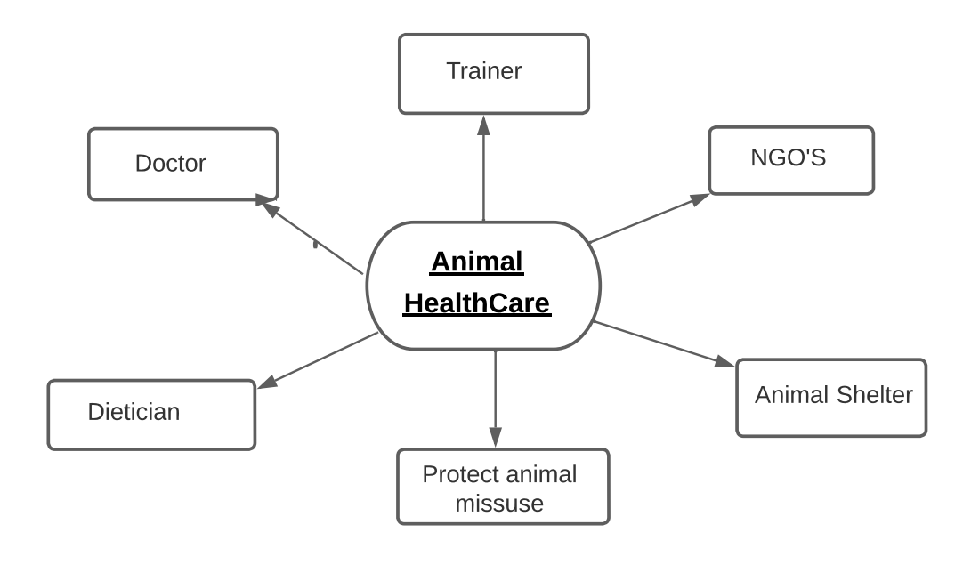

# WORKING PRINCIPLE

The picture taken by the user is uploaded and stored in the database which is then visible to the people and organizations linked to our website like doctors, dietitians, NGOs who provide all the possible solutions to the user according to themselves considering the situation of the injured animal. In case, a user finds a dead animal he can call for a last ride which on detecting his location provides the determined facilities.

# EXPECTED RESULT

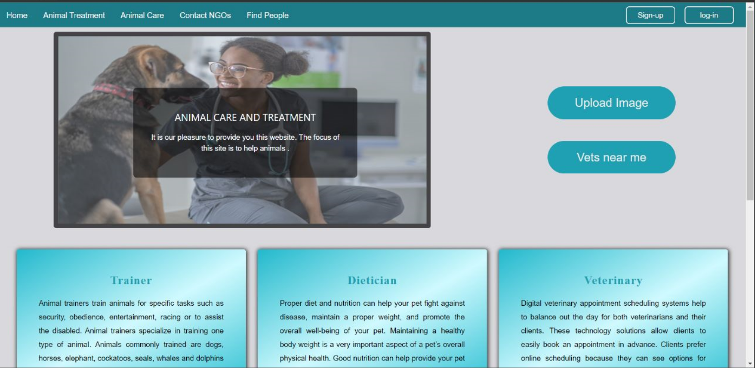

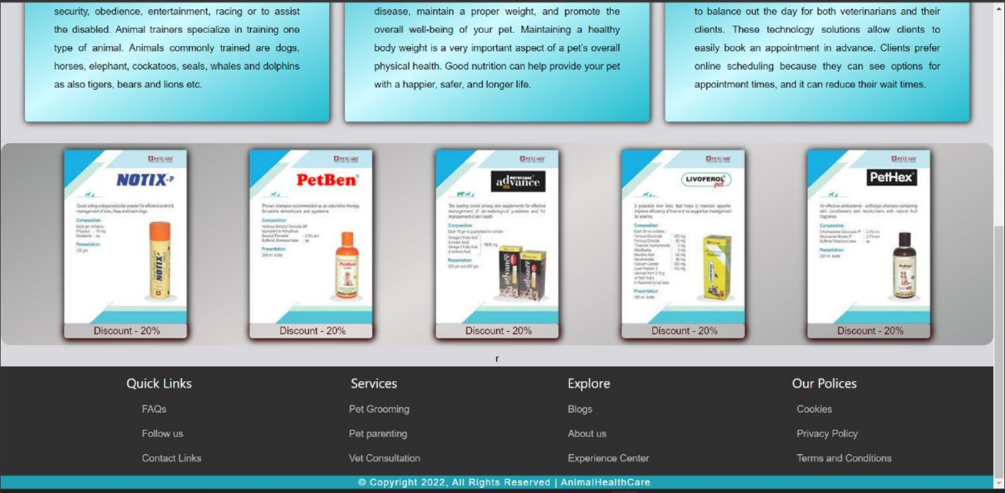

# CONCLUSION

There is a need in society for an ecosystem that can support all animals in a variety of ways in one location. We are attempting to create this environment through web development by enabling users to access all pet-related services. We are also doing our best to address the issue of street animals. Although there are many NGO's working for the welfare of animals in our society, many animals are still missed, so we are building a bridge to link all the missing animals to the NGO's. We also give users the ability to upload their animal-related products. As a result, both the consumer and the producer can satisfy every requirement.

# REFERENCE

* **<http://animalhealthcare.com/>**
* [**https://sarvoham.org/downloads/Pet%20Diet%20Chart.pdf**](https://sarvoham.org/downloads/Pet%20Diet%20Chart.pdf)
* [**https://petnutritionalliance.org/site/pnatool/creating-nutrition-plan/**](https://petnutritionalliance.org/site/pnatool/creating-nutrition-plan/)
* [**https://en.wikipedia.org/wiki/Veterinarian**](https://en.wikipedia.org/wiki/Veterinarian)
* [**https://www.careers360.com/careers/animal-trainer**](https://www.careers360.com/careers/animal-trainer)
* [**https://www.petaindia.com/?utm_source=PETA%20IN%3A%3AGoogle&utm_medium=Ad&utm_campaign=1121%3A%3Agen%3A%3APETA%20IN%3A%3AGoogle%3A%3ADSAGrant%3A%3Aeg%3A%3Asearchad&gclid=CjwKCAiA76-dBhByEiwAA0_s9S1Mq_f4CQL-Qe6CqWVRYuOMP02FO-HuZKNDcUSZMHpdEQLkzTFYHRoCt7YQAvD_BwE**](https://www.petaindia.com/?utm_source=PETA%20IN%3A%3AGoogle&utm_medium=Ad&utm_campaign=1121%3A%3Agen%3A%3APETA%20IN%3A%3AGoogle%3A%3ADSA-Grant%3A%3Aeg%3A%3Asearchad&gclid=CjwKCAiA76-dBhByEiwAA0_s9S1Mq_f4CQL-Qe6CqWVRYuOMP02FO-HuZKNDcUSZMHpdEQLkzTFYHRoCt7YQAvD_BwE)